

*Software Engineering*

Smart Robo-Advisor

SYSTEM CONSTRUCTION PLAN

**GROUP REPORT**

1801212963 Ye Juelin (叶珏琳)

1801212938 Wang Rusi (王如思)

1801212920 Shi Yunxia (史云霞)

1801212932 Wang Bingquan (王柄荃)

1801212832 Shen Zimin (谌子民)

# CATALOG

1. What is the system 3

2. System Function 5

2.1 Core function: Smart Investment Advisor 5

2.2 Additional functions 6

3. Systematic description 7

3.1 User Interface System 7

3.2 Middle Engine System 8

3.3 Underlying Data System 9

4. Justification of System Construction 10

4.1 Drawback of traditional investment service 10

4.2 Market Needs and Target Customer 11

4.3 How We Can Solve the Pain Points 11

5. Why We Can Build the System 13

# What is the system

From the perspective of finances, traditional labor investment advisory services are limited by management costs and the scarce availability for only high net-value individuals, hence, ordinary people do not have access to professional advisory services. From individual perspective, normal investors often lack of professional wealth investment knowledge, experience and operating capabilities, which is exactly the group that mostly worth targeting in financial service industry under the current context of Fintech era.

Our system is a **smart Robo-Advisor platform that intelligently provides a full range of customized financial portfolio advice for target clients** (defined in part 4.2), which is revolutionarily different from traditional investment advisor services. This system utilizes the Internet platform, financial models, quantitative trading strategies and Artificial Intelligence technologies to analyze, assess, and make decisions on asset active portfolio management. The use of IT and Artificial Intelligence algorithms can significantly improve the efficiency and performance of asset allocation, reduce operating costs, and enable customers to obtain specialized and personalized investment services of high quality at a very low cost. Meanwhile, as the user expands, this system can provide more accurate service to the user along with the accumulation of data.

The system mainly contains functions including **customer risk assessment, quantitative strategies building, asset allocation, portfolio selection through back-test results, portfolio tracking and timely advice sending**. The core strategy algorithm will cover all areas of classical quantitative trading models, e.g., multi-factor model, CTA model, statistical arbitrage model, industry rotation strategy, etc. The investment targets will include stocks, bonds and futures. Since customers’ risk taking level assessment is critical, the system will help users to identify their investment goals by analyzing factors such as investor’s age, salary, family status, asset liquidity and investment duration. And by combining the expected return rate, risk-taking level, periodic characteristics and correlation of different financial assets, this will system finally construct the best portfolio that matches the investment objectives of the users and give investment advice. These features are all managed automatically at a much lower cost, compared with traditional financial advisor service.

Apart from the robo-advisor function, this system also provides additional valuable services, such as strategy sharing forum, which can provide a platform for investors to share ideas and experience in investment to enhance user stickiness. Besides, users can sign up personal financial center to have a comprehensive monitoring and analysis of their historical portfolio performance directly on the platform.

# System Function

## 2.1 Core function: Smart Investment Advisor

The core function can provide customized portfolios advice for users based on their typical requirements, including risk tolerance level, investment style preference, asset liquidity, investment amount and time duration etc. It is mainly divided into two parts: Risk Preference Assessment and Portfolio Management Advice.

* **Risk Preference Assessment sector**: it is designed for new investors who has vague risk tolerance level self-recognition. In this part, after users filling in questionnaires related to individual financial conditions, the system will measure the user's real risk-taking level according to our intelligent risk assessment model. Further, this result will guide us to co-determine the final investment strategy as one of the key parameters.
* **Portfolio Management Advisor sector**: based on users’ input, e.g., risk preference, expected rate of return, frequency of changing portfolio, investment time duration and other important indicators, we can then give users investment advices on how to allocate their asset on different investment targets. In this case, we will display the back-test result graph of recommended investment strategies and relevant statistical information based on historical trading data.

However, since we do not have the trading certificate, after we come up with final investment portfolio by our model, we will timely send the portfolio investing plan and investing instructions to users according to their expected trading frequency. Consequently, they could build up their own portfolio with reference to our suggestions.

## 2.2 Additional functions

* **Personal Center**

In this module, users can query and modify their personal information. At the same time, users can also query the back-test results of our previous investment strategies to assess the performance of the portfolio based on historical data.

* **Strategy Book**

In this module, users can view our existing investment strategy models, the back-test result of our different strategies, as well as some key statistical performance indicators such as maximum withdrawal, annual return rate, Sharpe rate etc.

* **Strategy Sharing Forum**

In this module, users can share their own strategic ideas and experience, and they can also give compliment to other strategies ideas that they agree with.

# Systematic description

To achieve above functions, we divide our system into 3 main parts including user interface system, middle engine system and underlying data system.

## 3.1 User Interface System

In user interface system (see in Pic.1), the user could **input**:

* **Risk Assessment parameters** about their personal financial condition including income, age, investment experience, asset liquidity to calculate its risk preference.
* **Portfolio Management parameters** including investment amount, expected return, investment time duration, portfolio changing rate, risk preference etc. for the program to decide the customized strategy for specific user with best performance in the market.

User interface should **output**:

* **Strategy back-test results and strategy introduction**.
* **Advice message of the trading order** if the user accepts the strategy.

In addition, users could sign an account and have their own **personal center** where used strategies and relevant performance data are listed.

Besides, a **Strategy Sharing Forum** is also built for users to communicate and share their strategies and trading experience.

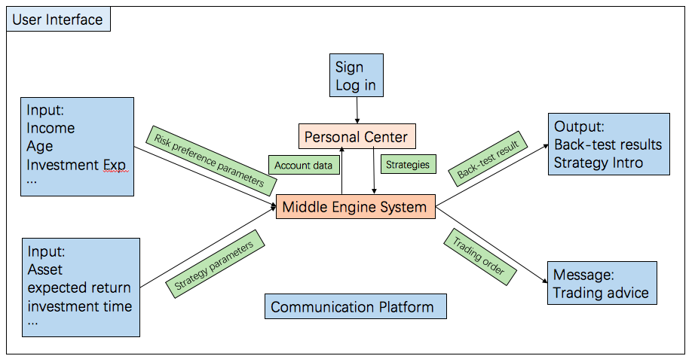

**Picture 1- User Interface System**

## 3.2 Middle Engine System

Middle engine system (see in Pic. 2) is the core of our project, which mainly contains supporting algorithms to realize the functions:

* **Risk Preference Calculation**: this algorithm could calculate users’ risk preference according to their input.
* **Strategy Implementation and Optimization:** this algorithm will start with implementing several main strategies including multi-factors strategy, timing strategy, CTA strategy, machine learning strategy and so on. After that, it will build an asset allocation frame to integrate these strategies and then use optimization method to decide the best strategy to use.
* **Back-test Visualization**: this algorithm will calculate the performance of strategies based on history data and visualize the result to the user interface.

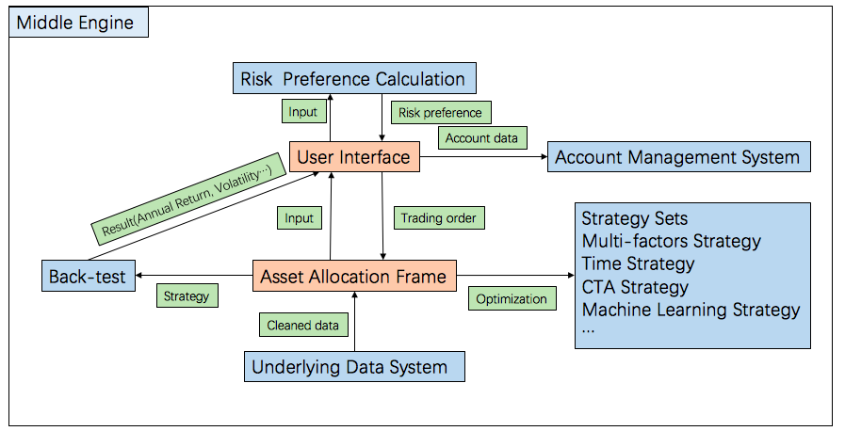

**Picture 2- Middle Engine System**

## 3.3 Underlying Data System

The underlying data system (see in Pic. 3) is more straightforward. It will get data from Wind or other finance data sources through API connectors and do some data cleaning for the use of middle engine system's strategies.

To store users' account data, it also needs to build up the user info database.

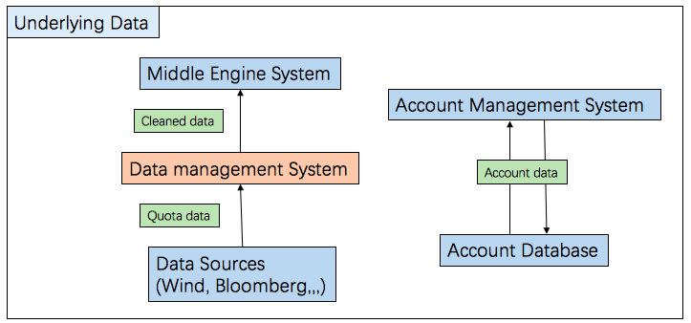

**Picture 3- Underlying Data System**

# Justification of System Construction

## 4.1 Drawback of traditional investment service

With the continuous development of China's financial market, it is increasingly difficult for individual investors or investors who have not received good financial education to benefit from the market. At present, there are as many as 3700 stocks and nearly 10,000 financial funds in the market. Faced with a wide range of financial products, customers may have difficulties in choosing financial products.

Immature investors without professional financial knowledge often traded stocks blindly without reasonable portfolio planning. In this way, they did not know how to properly allocate asset categories, investment timing and transaction prices, which resulted in huge risk exposure and even financial loss.

Consequently, many high-net-worth clients will choose to seek professional investment adviser for investment and asset management. However, because of the high labor costs, the management fee of traditional investment consultants is generally higher than 1%, while the marginal cost of this business will not significantly reduce. Therefore, such investment methods constantly require high investment thresholds and high agent costs, which will shut the door on ordinary investors.

## 4.2 Market Needs and Target Customer

In China, by 2020, the scale of intelligent investment management assets is predicted to exceed 5 trillion RMB. China's huge population and growing scale of asset management are the basis for intelligent investment in future development. However, at present, the development of China's smart investment is still in its infancy in terms of the technology maturity, the scale of management assets and also the number of users. Hence, the market is in an urgent need of a well-designed robo-advisor platform.

In order to achieve a wealth appreciation, everyone needs to invest. The majority of investors have the need for financial management and asset allocation, that is, the needs to obtain professional financial advisors services. Therefore, this system targets on all investors, both high-net-worth investors and ordinary investors with or without investment knowledge and experience. Accordingly, the highlight of this system is lowering threshold for beginner investors to use the AI quantitative trading system. We hope to solve the problems that investors have when they want to invest through the smart investment platform. For example, the existing funds do not meet the investment minimum standard, imperfect investment strategies, the purpose of the real-time monitoring of portfolio fluctuation cannot be achieved, etc.

## 4.3 How We Can Solve the Pain Points

In order to realize inclusive finance and enable most ordinary investors to realize asset preservation and appreciation, we utilize sequences of quantitative strategic model and relevant portfolio back-test results to accurately customize profitable portfolios for each individual according to their personal requirement input.

We provide different quantitative trading strategies according to their different risk preferences, return expectations, investment duration, investment amounts etc. Thus, the whole process investment of advisory services for investors can be realized, including selecting investment targets, recommending portfolio according to individual conditions, timely adjusting portfolio positions according to market changes as well as other follow-up long-term investment services.

In terms of the management costs, based on computer algorithm-assisted intelligent investment system, the management fee could generally be reduced to between 0.25% and 0.5%. Meanwhile, the marginal costs decrease with the increase of accumulated customers with obvious marginal effect.

# Why We Can Build the System

MOST of our team members are from Quantitative Trading Association (QTA) in PHBS, who are professional in financial model building and have adequately quantitative strategies knowledge as well as the relevant required coding experience. Therefore, we have qualified skills and background, and most importantly, abundant passion for building up this system.

We are committed to becoming the most trustworthy financial advisor for every investor as a smart Robo-Advisor investment platform. And Hopefully we can further become the promoters and executors of the society's inclusive finance.